Novel Studies

Song of the Trees
&
Roll of Thunder Hear My Cry
By:Mildred D. Taylor

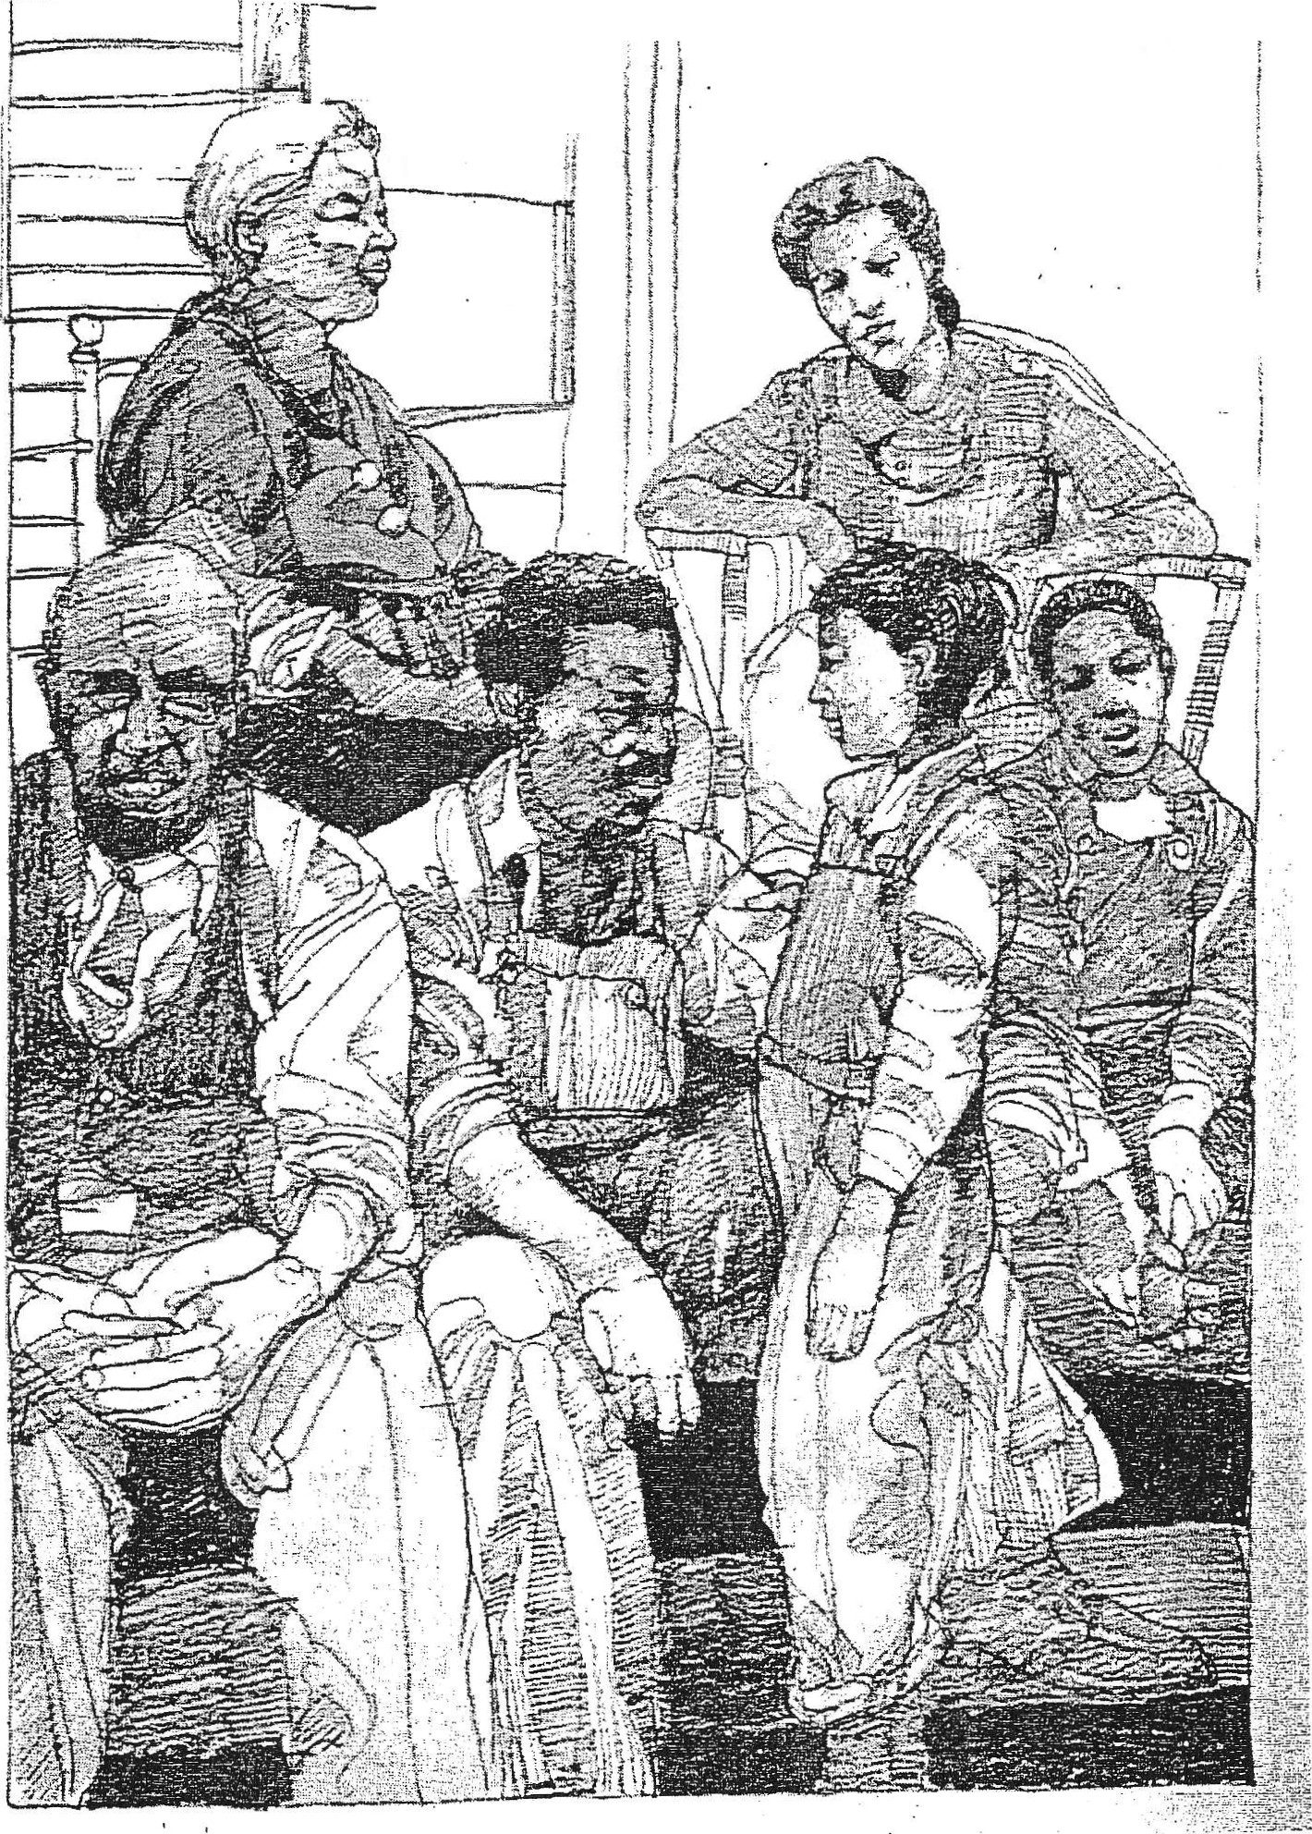'.!r;
'

Timeline for Unit Completion:

Day 1

.., Day2

Pre reading Activities Read Song of the Trees Complete Review Sheet
Day9

Review
Choice- . Complete section 4
"Whotdo You Know?" individually
or

,.-Review
Reading Quiz Song of the Trees

1 DayJ·
"Dealing with People Who Want
to do you Harm"
in a group no larger than 4 students.

Pre reading questions Vocabulary analysis sheet Read Chapter 1; Questions
Day tO
Review
Read Chapter 10; Questions

Day4

DayS

Review
Vocabulary activity
Read Chapter 2-3; Questions

Review
Quiz c 1,2,3
Literature Circle #1
Read C pter 4; Mississippi
,trivia q estions
Day 11
Review
Read Chapter 11& 12; Questions for 11 & 12

Day12
Review Sheet- What do You
Know?
Co-at of arms- Fill in using
pencil, sketches, clip art, or thin
tip markers. Use a key to define symbols.

.I '
Day6_
Review
Literature Circle #2
Read Chapter 5; Literary
Analysis Sheet (Colloquialisms)

Day7
Review
Critical Thinking Vocabulary
Sheet
Read Chapter 6 & 7; Questions for6 & 7
*Class activity game board using sticky notes.

Day 13
September Book Report­ Bookmark Activity
Unit completion and makeup
work

Day 14
Final Test
Bookmark due

DayS

Review
Quiz Chapter 1-7 (True & False) Read Chapter 8 & 9; Questions for 8 & 9

Name
Class _

Date ---------------------------------- Literature: Song of the Trees Review Questions

Answer the following questions on a sheet of loose-leaf paper:

1 Who is the author of Song of the Trees? Tell why she is a well-known and very respected author.

2 Describe the setting for this story (time and place).

3 List all of the main characters and a sentence or phrase about each of them.

4 Tell about one instance in which Cassie's family had to deal with racist attitudes or actions. Do you feel that this would be different today? Why or why not?

5 Why did David Logan need to work on the railroad, away from his family?

6 What unexpected action did David Logan take to protect the trees, when he returned home?

7 What were his (David Logan's) motives? What feelings and values were behind this action, and what was he hoping to accomplish?

8 Choose one character that you admire or respect. L ist 5 of his or her characteristics.

9 Read the last few pages of the story again. What challenges does the Logan family still face?·

1 0 Is this a book that you would recommend to others? Why or why not?

Roll of Thunder, Hear My Cry
/I
About the Author

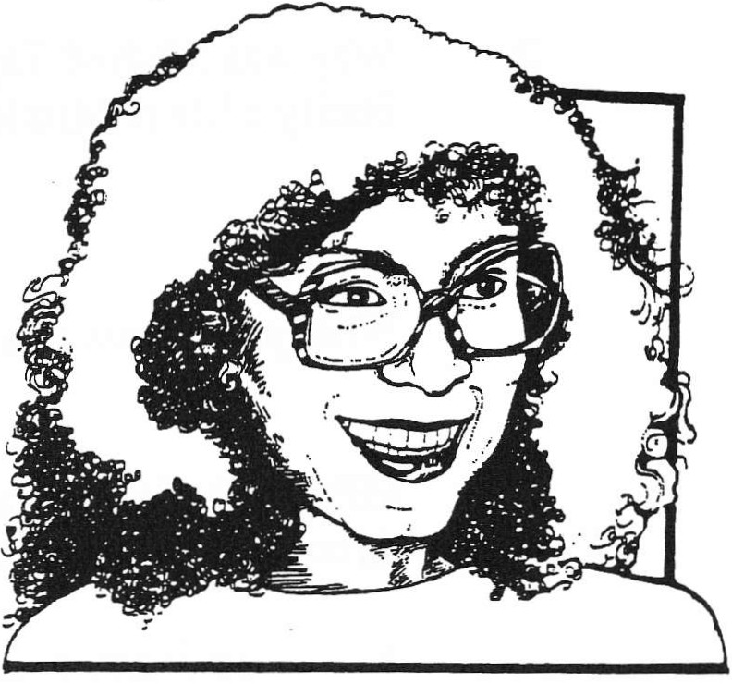Mildred D. Taylor was born in Jackson, Mississippi, and educated in Toledo, Ohio. She went to the University of Toledo and received her Master's degree at the University of Colorado School of Journalism, in Boulder.

Ms. Taylor began her career with the Peace Corps, as an English and history teacher in Ethiopia for two years. She returned to the United States and was a Peace Corps recruiter. She then became a study skills co-ordinator for the University of Colorado Black Education Program.

Ms. Taylor published her first book, Song of the Trees, in
1975. Like Roll of Thunder, Hear My Cry, the book concerns the Logan family and-is told by Cassie, the first person narrator. Roll of Thunder, Hear My Cry was
Ms. Taylor's second novel and it won the Newbery Medal in 1977. Her third book, Let the
Circle Be Unbroken, published in 1982, continues the Logan story when Cassie is 11 and Stacey is 14. Two short novels, Mississippi Bridge (1987) and The Friendship (1990) are also about the Logans.

Ms. Taylor uses her early life as the inspiration for her stories. She credits her father for teaching her a truer history of the black people in the United States than she learned in school. Her family has a long history, stretching back into the days of slavery, in Mississippi, which is the setting of Roll of Thunder, Hear My Cry. In all of her books, Ms. Taylor draws her reader
into the circle of an inspiring black family, full of strength and love. She shows us their traditions, heritage, and community.

When asked about her writing, Ms. Taylor replied,

"In Roll of Thunder, Hear My Cry, I included the teachings of my own childhood, the values and principles by which I and so many other black children were reared, for I wanted to show a different kind of black world from the one so often seen. I wanted to show a family united in love and self-respect; and parents, strong and sensitive, attempting to guide their children successfully, without harming their spirits, through the hazardous maze of living in a discriminatory society....It is my hope that to the children who read my books, the Logans will provide those heroes missing from the schoolbooks of my childhood. Black men, women, and children of whom they can be proud."
(Quotations and information from Something About the Author, edited by Anne Commire, Gale Research, Detroit:
1971 and Twentieth Century Children's Writers, edited by D.L. Kirkpatrick, Saint Martin''s Press, New York: 1983)

#439 LiteratJJ.re Unit 6 "1994 Teacha Created Materials, Inc.

Name:------------- Date: Lit. Period:

1 Which of Mildred D. Taylor's relatives is also a "master storyteller"?

2 Why was Mildred Taylor able to write so convincingly about the Logan family's life in Mississippi in the 1030's?

3 What prestigious award did Roll of Thunder. Hear My Cry win in 19TJ?

4 Mildred D. Taylor was a volunteer English and history teacher in Ethiopia through: (Circle)

A the Jesuit Volunteer Corps B AmeriCorps

c the Peace Corps D Maryknoll

5 Name two values that are very important to Mildred D. Taylor:

• '

Book Summary Roll of Thunder, Hear My Cry
Roll of Thunder, Hear My Cry

by Mildred D. Taylor

(Penguin, 1976)

(Available in Canada, Penguin; UK and Australia: Penguin Ltd.)

Roll of Thunder, Hear My Cry is only one of Mildred Taylor's novels about the Logan family. All of these books about the Logans use the character of Cassie as the narrator. This novel takes place in western Mississippi, near Vicksburg, in 1933. It is basically a story of how Cassie learns about the inherent prejudice of whites against blacks in the South during the difficult times of the Depression.

Cassie Logan is a nine-year-old girl who lives with her mother, a seventh grade teacher, and her father, . who must work ori the railroad to supplement the family's farming income. Also in the house are Cassie's paternal grandmother, and three brothers-Stacey, 12, Christopher-John, 7, and Little Man, 6. The Logans own 400 acres, and are one of the few black landowning families in the community of sharecroppers. While Cassie is secure in the love of her close-knit family, she describes a year of perplexing and hurtful insults, some serious and some small.

Most serious is the rising tide of racial unrest brought on by the hard times of the Great Depression. "Night men" burn the men of the Berry family, killing one and badly disfiguring another. Papa returns with the gigantic, but kind and wise, Mr. Morrison to watch the family while he is away. The Wallaces, who are implicated in, but not prosecuted for the burnings, own a store where they encourage the black children to drink and gamble. With the help of Mr. Jamison, a white lawyer, Mama organizes a boycott of the Wallace's store. This costs Mama her teaching position.

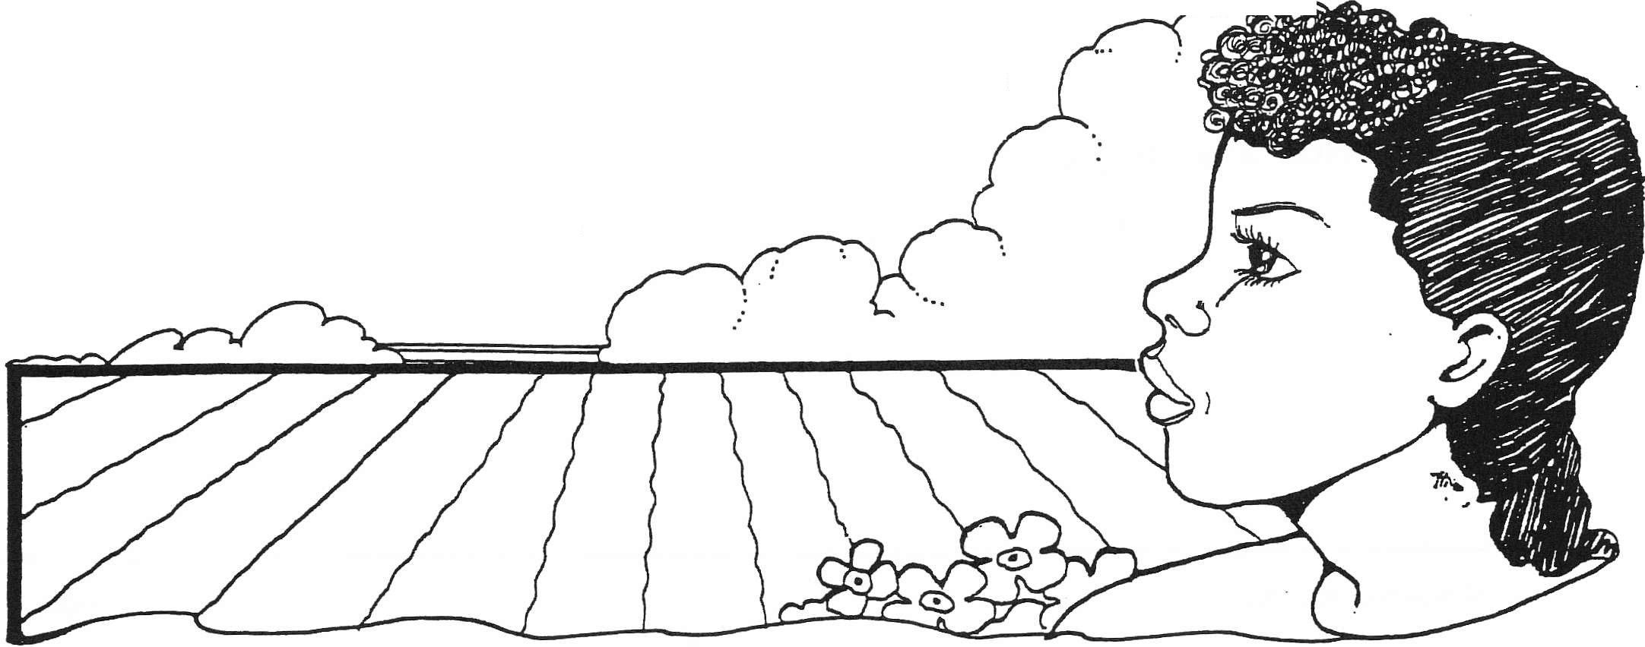"Night men" attack Papa while he, Stacey, and Mr. Morrison are returning from Vicksburg with supplies. Papa suffers a broken leg which keeps him from returning to the railroad. The situation becomes worse when Harlan Granger, a white plantation owner who wants the Logan land, persuades the bank to call in their mortgage. Uncle Hammer, who works in Chicago, must sell his silver Packard to pay off the debt. The novel ends with the near-lynching ofT. J. Avery, a neighbor just a year older than Stacey, who is framed by some white youths. Papa sets fire to his field of cotton which adjoins the Granger plantation. This diverts the mob and the entire community works together to save the crops.

Cassie, a resourceful child, must deal with all the events and attempt to sort out her place in this world. The novel concludes with Cassie still searching, but with the help of her strong and caring family, it seems as though she will rise above the indignities of the segregated society.

C19 94 TetJcher CretJted Materials, Inc. 7 #439 Literature Unit

Name
Roll of Thunder, Hear My Cry
Activity Sheet #1
Complete Prior to Reading

Getting Ready to Read the B_ook
(Getting the lay of the land; preparing)

1 . What do you know about the book?
Author

Length -------------------------------------------------­ Popularity ----------------------------------------------­ Teaser on the cover -----------------------------------------

Excerpts from reviews ------------------------------------

Awards _

Author's note on pages vii and viii

2. What do you expect of the book? Why?

3. Note any background information you need or want.

e Novel Units,Inc. All rights reserved
3

Name _ Roll of Thunder, Hear My Cry
Activity Sheet #2
Complete Prior to Reading

Anticipation Guide

Directions: Prior to reading the book, read each statement, marking agree or disagree. After reading the book, return to the statements and react again. Did the book influence you to change your opinion? If so, why?

Before Reading After Reading

Agree | Disagree | No opinion | Statement | Agree | Disagree | No opinion
 |  |  | Real friends always support and help each other.
 |  |  | It is never defensible to conceal the truth.
 |  |  | The lot of black men changed little from slavery to 1933.
 |  |  | All children follow the examples of their parents.
 |  |  | Civil disobedience has a place in promoting needed societal change.
 |  |  | Racial hatred is taught by parents, when children are very young.
Segregated schools in the
South were separate but equal.
 |  |  | The power of the purse (buying power) is mighty indeed.
 |  |  | There is nothing like owning your own land.
 |  |  | Might is right.

© Novel Units, Inc. All rights reserved
4

Name _
Roll of Thunder, Hear My Cry
Activity Sheet #7 • Page 1
Use After Reading Chapter 1

Vocabulary

Directions: Look over the following list of words from the book. Put a check if you know the word for sure and a star if you've seen the word but aren't sure of its meaning. The words you don't know at all will be your first challenge. As you read, devise a meaning from context or consult a dictionary. Your second challenge is to become sure of the meaning of the starred words.

meticulously- . conspiratorially glade jauntily
oblivious chignon - ·
mutely-

sharecropping

unmercifully

despondently reverently temerity indignant humiliation revival
nape-

amiably banished defiantly frenzied interminable
·emaciated.
unsympathetic subtle despicable goaded
morosely

circumstances ..,.

emitted lethargically ominously mortgage
flailed-
.J
stealthily-

condescending

inaudible- -

raucous.
kin –
riveted ·

affirmation caldron- sinewy

amenities
gloat

languidly _ intriguing jovial
relent assurance

maverick testily engrossed vulnerability
flaunting.;

ridiculed- _

immobilized

ploy

Novel Units, Inc. All rights reserved
19

Name _
Roll of Thunder, Hear My Cry
Study Guide • Page 1
Chapter 1

Chapter 1

1 . Who is telling the story?

2. What do you know about Cassie?

3. What is the time and place of the novel?

4. What is the style of the novel?

5. How are the black children and schools treated?

6. Explain the last sentence of the chapter.

© Novel Units, Inc. All rights reserved
5

Name

formidable exasperation
mercantile - s+o-re
crescendo -

obnoxiously penetrating ledger audible
eblivious

nauseous-

prone . admonished ginned
rile

bland -.

transfixed malevolently
resiliency
Roll of Thunder, Hear My Cry
Activity Sheet #7 • Page 2
Use After Reading Chapter 1

candidly

chiffonier-

chain gang retaliated traipsing wary
congregation

feat-
reprimand-

placid

inaccessible persistent
snidely
phenomenal-

revenge adamant .·
feigned .

menacingly insolently embittered
adamantly

© Novel Units, Inc. All rights reserved
Name _ Roll of Thunder, Hear My Cry
Study Guide • Page 2
· Chapters 2-3

Chapter 2

1. Who picked the Logan cotton in 1 933?

2. Identify Mr. L.T. Morrison.

3. What was Papa's warning about the Wallace store?

Chapter 3

1. What was particularly irksome about the white school bus in rainy weather?

2. Why do the white children taunt Cassie and her friends?

3. What was Stacey's plan for revenge against the white school bus?

4. How does Stacey's revenge plot work out?

5. Why do Mama and Mr. Morrison get out their firearms in this chapter?

© Novel Units, Inc. All rights reserved
6

Name

Literature Period# -------

Date ------

Practice Essay Question: Roll of Thunder. Hear Mv Cry

On the lines below, write a topic sentence, three supportine sentences, and a concludine sentence for the following question about Roll of Thunder, Hear My Cry.

Why did Stacey and the other Logan children want to get revenge on the Jefferson Davis County school bus driver and passengers?

TOPIC SENTENCE:
Tell what your paragraph will be about. State your main idea, without getting into specific details. You might want to repeat part of the question in your topic sentence. (Indent.)

BODY OF THE PARAGRAPH (Supporting Sentences):
Give details and specific examples from the story to support your topic sentence. Refer to chapter 3 of Roll of Thunder. Hear My Cry.

1

2

3

CONCLUDING SENTENCE:
The concluding or closing sentence comes after all supporting details have been given. It reminds the reader of the paragraph's main idea and brings the paragraph to a logical ending point. No new details should be introduced here.

Checklist:

Check ea,ch of the following, when you're sure that you have completed each item.

My supporting details are accurate.

I started every sentence and name with a capital letter.

All of my sentences end with the appropriate punctuation mark. I have done my best to spell each word correctly.
All of my sentences sound like complete sentences. I have written neatly and legibly.

Section 2: Chaptez8)_ 5 Roll of Thunder, Hear My Cry
Mississippi Facts

Directions: Use appropriate reference books to locate the following information about the state of Mississippi.

Population:
(ranks ----------in population)

Area:

square miles (ranks in size)

Capital:-------------------------------­ (How many people live in the capital city? State Nickname:
State Flower: _

State Motto: ------------------------------------------------------ Highest Point in Mississippi:---------------------------------------------­ Lowest Point in Mississippi: -------------------------------------------­
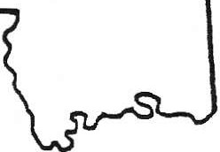Time Zone: --------------------------------------------------------

Three largest cities and their populations:

1.
2.
3.

Find the city of Vicksburg on a map of Mississippi. This small city is near the middle of Mississippi's western border. It is just west of the fictional Strawberry in the novel.
VIcksburg

• Vicksburg is next to what river? ------------------------
• What state is on the other side of the river? _

• What state is about 60 miles (96.5 km) northeast of Vicksburg? _

• What important city is 40 miles (64.3 km) east of Vicksburg? _

• What city might our 42nd President be interested in visiting about 30 miles east of
Vicksburg? _

iOO #4.39 Literature Unit 18 «:11994 Teacr Created Materials, Inc.

Name _
Literature Period# _

Date -------

Practice Essay Question: Roll of Thunder, Hear My Cry

On the lines below, write a topic sentence, three supporting sentences, and a concluding sentence for the following question about Roll of Thunder, Hear My Cry.
Why did Stacey follow T.J. to the Wallace store?· TOPIC SENTENCE:
Tell what your... paragraph will be about. State your main idea, without
getting into specific details. You might want to repeat part of the question in
your topic sentence. (Indent.)

BODY OF THE PARAGRAPH (Supporting Sentences):
Give details and specific examples from the story to support your topic sentence. Refer to chapter 4 of Roll of Thunder. Hear My Cry.

Name _
Roll of Thunder, Hear My Cry
Literary Analysis, Activity Sheet
Use After Reading Chapter

Literary Analysis

The characters in Roll of Thunder, Hear My Cry often use informal expressions called colloquialisms. People who live in different regions of the country often use colloquialisms that might not be used or understood in other areas.

Translate each colloquialism on the chart below into a more formal way of speaking that everyone would understand.

Page | Colloquialism | Translation
6  76  80  5  37  59 | "He's low sick all right."  "...y'all ain't gotta cowtail to a lot of this stuff."  "Can't I just go up and say 'Hey'?"  "...we knew Big Ma had gone to a sick house last night."  "...he's got no stomach for this kinda thing."  "he'd take ole Little Man and swing him over ttiat tree yonder like he wasn't nothin' but a twig."

© Novel Units, Inc. All rights reserved
22

Name
Roll of Thunder, Hear My Cry
Critical Thinking, Vocabulary Activity #8
Use After Reading Chapter 6

Critical Thinking

A. Directions: Complete the following vocabulary challenge grid, working individually or in pairs.

Word | Synonym | Antonym | Example | Related Word
Sharecropping
Maverick
Chiffonier
Ploy
Mercantile
Nape ' |  |  | , .

B. Directions: Sort out the following adverbs. Try to line them up in chains of degree of emotion and feeling.

MOROSELY • AMIABLY • CONSPIRATORILY • STEALTHILY DEFIANTLY • MUTELY • SNIDELY
OMINOUSLY • REVERENTLY • LANGUIDLY

1) _

2)

3)

© Novel Units,Inc. All rightS reserved
21

Name _
Roll of Thunder, Hear My Cry
Study Guide • Page 5
Chapter 6

Chapter 6

1. What are the things that Stacey (on page 89) says Cassie doesn't understand?

2. Who is Uncle Hammer? Choose two adjectives to summarize his nature.

3. How does Mama explain to Cassie about Mr. Simms and Big Ma's handling of the situation? Find the quotations in the book.

4. What is the significance of the new coat incident? How will the situation be resolved?
Make a prediction.

Novel Units, Inc. All rights reserved
9

Name. _ Roll of Thunder, Hear My Cry
Study Guide • Page 6
Chapter 7

Chapter 7

1. What is Uncle Hammer's reaction when he learns that Stacey has given his new coat to T.J.?

2. What is special about the Logans' Christmas?

3. What is Mr. Jamison's surprising offer to Papa and Uncle Hammer?

4. What was the interchange between Mr. Granger and David and Hammer Logan at the end of Chapter 7?

5. What is the conflict in the story adding up to be?

© Novel Units, Inc. All rights reserved
10

Name
Roll of Thunder, Hear My Cry
Study Guide • Page 7
Chapter 8

Chapter 8

1. What is Cassie's revenge on Lillian Jean?

2. Why doesn't Lillian jean understand Cassie's taking revenge?

3. What were the reasons given when Mama was fired? What were the real reasons?

4. Why does Stacey part company with T.j.?

e Novel Units, Inc. All rights reserved
11

Name _ Roll of Thunder, Hear My Cry
Study Guide • Page 8
Chapter 9

Chapter 9

1 . What do the Logans find unique about Jeremy?

2. What is the relationship between R.W. and Melvin and T.J.?

3. · Reread the extended simile Papa uses on page 156. What does it mean? How do similes enrich our understanding?

4. What are some examples of foreshadowing in this chapter?

5. What happened on the way home from Vicksburg?

Cl Novel Units, Inc. All rights reserved
12

Section 4: Chapters 8 - 9 Roll of Thunder, Hear My Cry
What Do You l<now?

Answer the following questions about Chapters 8 and 9.

1. On the back of this paper, write a one paragraph summary of the major events that happened in these two chapters. Then complete the rest of -the questions on this page.

2. Why is Lillian Jean surprised when Cassie asks if she can carry her books?

3. What is Cassie's real reason for acting like a servant for Lillian Jean?

4. Do you feel that Cassie's plan for revenge on Lillian Jean was a good one? Explain.

5. Why did T.J. want to get Mrs. Logan into trouble?

6. What do you think is the real reason Kaleb Wallace and Harlan Granger have Mrs. Logan fired?

7. How are R.W. and Melvin Simms treating T.J.? Why?

8. Why does Mr. Avery tell the Logans he can no longer shop in Vicksburg?

9. What happens to Papa on _the way back from Vicksburg?

10. What are Christopher-John and Little Man most afraid of when Papa comes home from
Vicksburg?

#439 Literature Un it 01994 Teacher Created JV!aierillls, Inc.

Section 4: Chapters 8 - 9 Roll of Thunder, Hear My Cry
Dealing With People
Who Want To Do You Harm

In Chapter 8, Cassie begins a plan to pay Lillian Jean Simms back for humiliating her in Strawberry. Lillian Jean took advantage of her position in the "Jim Crow South" to make Cassie feel inferior. However, after the initial anger wore off, Cassie figures a way to get even.

Divide into groups of three or four. Choose one person to write down the thoughts your group discusses about the following topics. Use the back of this page, if necessary.

1. Discuss how and why Lillian Jean humiliates Cassie in Chapter 5.

2. In your group, discuss what you think of the way Cassie gets even.

3. Discuss how Cassie is wise enough to understand her"opponent" so well that she knows
Lillian Jean will not tell anybody about what Cassie did.

4. Is Cassie's plan of retaliation successful? (Here you must discuss the way Lillian Jean reacts when the "game" is over.)

5. Although Cassie is stronger than Lillian Jean, the white girl acts like a bully in Strawberry because she knows the black girl probably will not hurt her. Discuss different ways a bully will "pick" on someone "weaker."

6. Many psychologists say that a bully acts the way he does because he feels bad about himself. A bully picks on others when there is something going on in his own life that he dislikes but cannot do anything about. Does your group think this is true about bullies? Discuss.

7. It doesn't matter why bullies act the way they do when it is you they are picking on. A bully can make a person's life miserable, especially when the victim cannot think of how to make the situation better. Discuss in your group what can be done to make a bully stop pestering a person.

,.

Name
_ Roll of ThundeHear My Cry
Study Guide • Page 9
Chapter 10

Chapter 10

1 . What is the mood of Chapter 1 0?

2. What were the seven separate incidents which the author puts together in this chapter? Why are they grouped together and what do they mean?

a) b) c) d)
e) f) g)

© Novel Units,Inc. All rights reserved
13

Name _
Roll of Thunder, Hear My Cry
Study Guide • Page 1 0
Chapters 11-12

Chapter 11

1. Why does Mr. Morrison sit on the porch, watching and guarding?

2. How does T.j. figure in the trouble?

3. Why does Stacey help T.J.?

4. What kind of a person is Mr. Jamison?

5. Why is it appropriate that the thunder crashed at the end of Chapter 11?

Chapter 12 -

1. What is Papa's immediate reaction when he learns Stacey and T.J. are hiding in the woods?

2. What is the apparent cause of the fire? What is the real cause?

3. How does the story resolve itself?

©Novel Units, Inc. All rights reserved
14

Section 5: Chapters 10 - 12 Roll of Thunder, Hear My Cry

What Do You l<now?
Answer the following questions about Chapters 10, 11, and 12.

1. On the back of this paper, write a two paragraph summary of the major events that happened in these three chapters. Then complete the rest of the questions on this page.

2. When Kaleb Wallace will not move his truck and let Mr. Morrison by with the wagon, what does Mr. Morrison do?

3. Why do you think Jeremy spends so much time in his tree house?

4. What are some reasons Cassie likes the annual revival meeting?

5. How does Uncle Hammer raise the money to pay the mortgage?

6. Why does Cassie feel sorry for T.J. when he comes to the revival meeting?

7. Briefly describe what happened when T.J. and the Simmses go to the Barnett's store to get the pearl-handled pistol.

8. Who is able to stop the Wallaces from immediately killing T.J.?

9. Why do you think Papa starts the fire in his own cotton field?

10. At the end of the last chapter, why do you think Cassie cries for T.J., even though she never liked him?

C1994 Teacher Created Materials, Inc. 31 #439 Literature Unit

Section 5: Chapters 10- 12 Roll of Thunder, Hear My Cry

Family Coat of Arms

Although Cassie has a difficult life in the racially divided Mississippi of 1933, she has the strong support of her family. There are many values that the Logan family share. Some are:
education carzng honesty

love

importance of traditions
sense of history self-respect
completion of tasks strength of beliefs

Decide which of these are most important for a supportive family to share with each other. Perhaps you can think of others.

Design a coat of arms for the Logan family, using a visual interpretation of the different values. You could represent education by using a d ploma or a book. Caring could be represented by a mother standing at the bedside of a sick child or a parent and child playing ball together. Fill in the form below with at least four different pictures.

Extension: Create a coat of arms for your family using at least four different pictures.

#439 Literature Unit 32 <01994 Teacher Created Materials, Inc.

Name: -------------------------------------- Class: ---------

Character: -----------------------------------

Character Bookmark
Roll o(Thunder. Hear Mv Cry

The Assignment:

Create a large bookmark including the following:

* A three-paragraph introduction to your character, written in the flrst person and present tense, and containing the following information:

Name, family, where and when he/she lived
Include 2- 3 major events in the story and describe your character's involvement in these events and how he/she felt at the time.

Imagine that your are acting the role of this character in a play based on Roll of Thunder. Hear My Cry. Get in touch with this character 's values, dreams, and feelings. Use descriptive language and carefully-chosen incidents from the story to make your character come alive. Include a quote from the story. Make sure you have a strong voice in your writing, and that a reader familiar with the book would believe that your writing sounds like your character. We'll be discussing examples in class.

After your writing is done, draw a picture of your character. Add a symbol that visually gives more information about this character. (For example, for Big Ma, the trees and cotton growing on the Logan family land might be appropriate.)
Your bookmark will be graded using the following criteria: Prewrite (5 points)
Includes biographical info, events from the story, descriptive words about the character's
personality and feelings, a quote, and the symbol that you will be using in your illustration

Six Traits
Ideas (5 points)
Word Choice (5 points)

Organization (5 points) Fluency (5 points)

Voice (10 points) Conventions (5 points)

